8TH GRADE ACTIVITY: CAREER COLLECTIONS
Family Support Component

Section One: Barriers & Benefits
Welcome! Your student has been invited to participate in Career Collections, a two-section college- and career-awareness activity. Section One of this activity highlights various barriers and solutions that your student may encounter during their college and career exploration.

Throughout this activity, your student should reflect on the following questions:
- What are the challenges I will face in trying to go to college or pursue other postsecondary (that is, after high school) education options?
- What can help I overcome those challenges?
- How will college or other types of postsecondary education benefit me in my career?

After this activity, your student will be able to:
- Recognize challenges that might prevent them from pursuing postsecondary education.
- Identify solutions that can help them overcome those challenges.
- Understand the benefits of pursuing postsecondary education.

After this activity, as a family support individual, you will be able to:
- Discuss challenges that might prevent your student from pursuing postsecondary education.
- Offer solutions that can help them overcome obstacles in their pursuit of postsecondary education.
- Communicate the benefits of pursuing postsecondary education with your student.

In this section, your student will fill out a Google Form survey to explore the challenges and benefits of postsecondary education. This activity should help you and your student consider the challenges of pursuing postsecondary education, the resources available to overcome those barriers, and the benefits of pursuing postsecondary education.

As your student completes the survey, please take a moment to fill out and submit your own separate version of the survey. After you and your student submit your answers, click “View Score” to see common answers from students like yours, as well as links to additional resources. (Your score will appear as "0/0" since answers vary, but you can scroll down to see answers and links.)

Click HERE or go to http://k20.ou.edu/benefitsbarriersform to access the Google Form survey and answer the questions.

Once you and your student have completed the survey activity, please take a moment to discuss the follow-up questions below with them. These questions pertain to education barriers and solutions.

Barriers & Benefits Follow-Up Questions
Students often face several barriers when applying for and attending college, or when seeking other postsecondary education options. However, many resources exist that can help your student overcome those barriers.
- Are you currently concerned about any challenges or issues that could keep you from pursuing a postsecondary education? If so, let’s talk about it and find a solution.
- How will you personally benefit from pursuing a postsecondary education?

Section Two: Careers
In Section Two of the Career Collections activity, your student is invited to explore several unique careers clusters and learn about their postsecondary education requirements, such as a bachelor’s degree (4-year college), associate degree (2-year college), career technical center (career tech center, etc.), military training, and more.

Throughout this activity, your student should reflect on the following question:
- What postsecondary education and job skill requirements are needed for different careers?

After this activity, your student will be able to:
- Identify the required postsecondary education, skills, and majors associated with different careers.

After this activity, you as a family support individual will be able to:
- Identify 1–2 career clusters and discuss with your student the education, skills, and majors associated with those careers.

What are Career Clusters?
Career clusters are groupings of similar careers. For example, a nurse and a doctor would both fall under the Health Science career cluster. There are 16 total career clusters, which are made up of several occupations, programs, and majors related to that field.

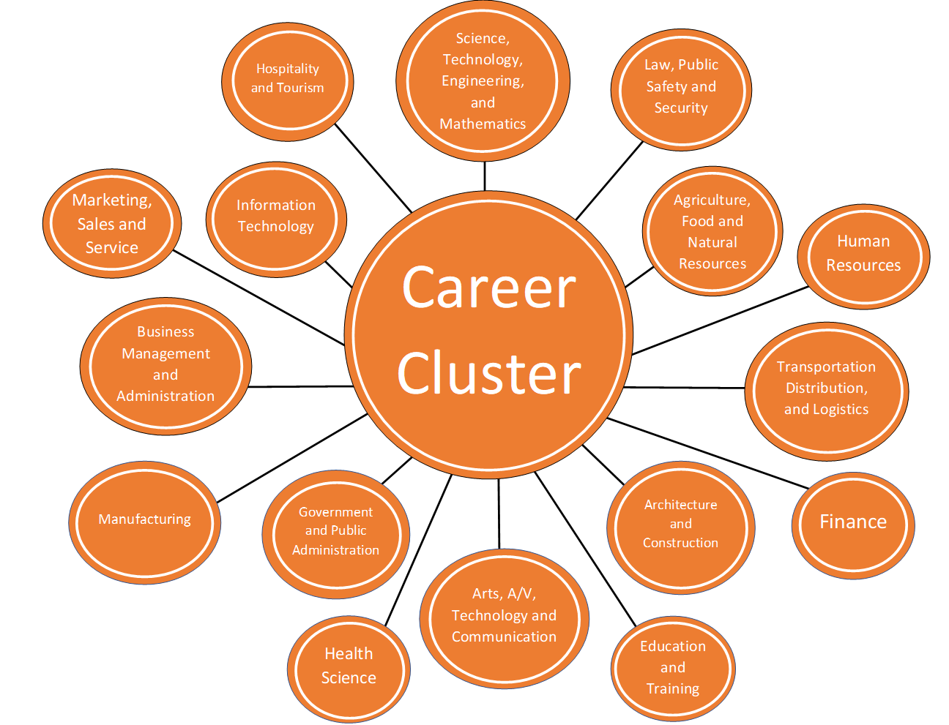

Guess That Career
Students, along with their supporters, need to know that it is never too early to explore career pathways. Today, most careers require additional education or training beyond high school—for example, a 4-year bachelor's degree, 2-year associate degree, career tech certification or diploma, or military training.

In this section, your student will explore various careers from nine different career clusters, and then learn about the required education, important skills, and average salary for each of those careers. Before your student begins the activity, please take a moment and follow the steps below to see if you can solve Career Clue Card #1. Then, invite your student to begin. Once you and your student have completed this activity, please discuss the follow-up questions on the next page.

- Read Career Clue Card #1. Make your best guess at what career it describes and write or type your guess in the space provided.
- Complete the jigsaw puzzle linked in the Career Clue Card to find out if your answer is correct. The correct answer will be revealed once you complete the puzzle!
- If the revealed career interests your student, you can explore similar careers under the same career cluster by clicking on the link provided in the Career Clue Card.
- Repeat steps 1-3 for the remaining Career Clue Cards.

Career Clue Card #1
Hospitality and Tourism Career Cluster
A professional in this field has a keen sense of taste. Their daily responsibilities may include creating menus, directing the preparation of dishes, ordering supplies, setting menu prices, and keeping records and accounts. For this job, a certificate or associate degree is required. Common majors for those in this career include culinary arts, baking and pastry arts, restaurant and hotel management, or professional cooking. The average salary for this career in Oklahoma is $42,140.

Career Title: ______________________________________________________________
To solve the jigsaw puzzle and reveal this career, click HERE or go to https://tinyurl.com/careerclue1.

To explore more about the Hospitality and Tourism Career Cluster, click HERE or go to https://tinyurl.com/hospitalitycareercluster.

Career Cluster Follow-Up Questions
- Let’s talk about two career clusters you learned about in the activity that might interest you. What are the educational requirements for a career in those clusters?
- Before you completed this activity, was there a certain career you wanted to pursue? After learning more about that career and others, have you changed your mind?

